Assignment 1:

1. Armed
2. Door
3. Glass
4. Motion

Y = (A AND(B OR C OR D))

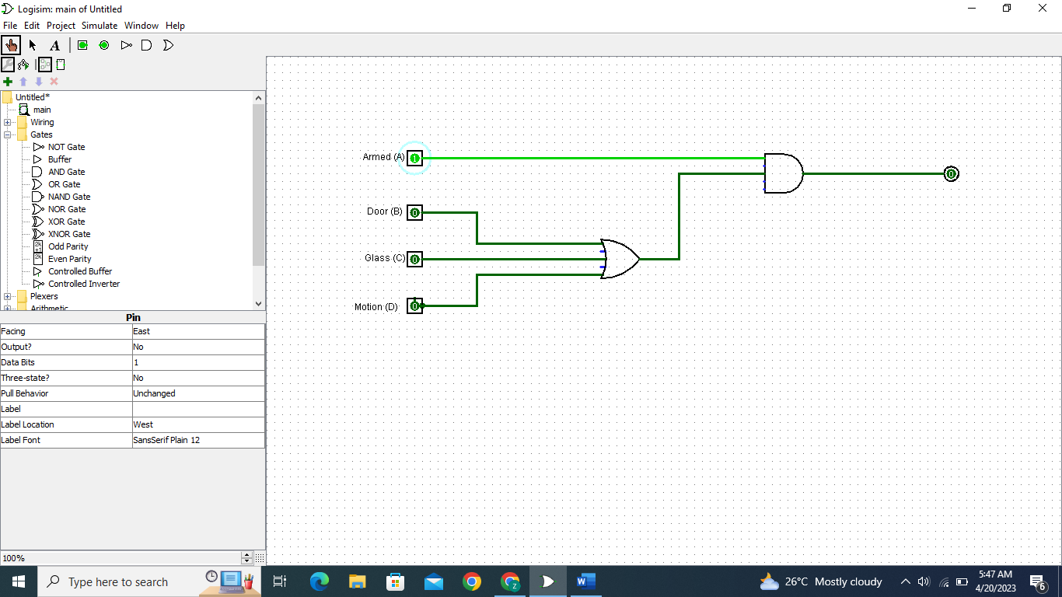

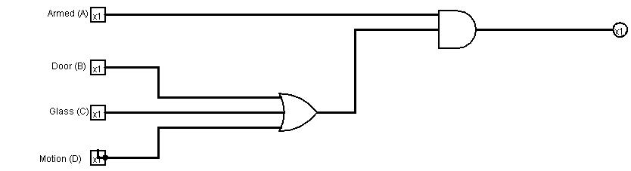

This is my first assignment as both screenshot and jpeg.

The input lines do not work whether the Glass, Door, or Motion is stimulated unless Alarm is Armed.

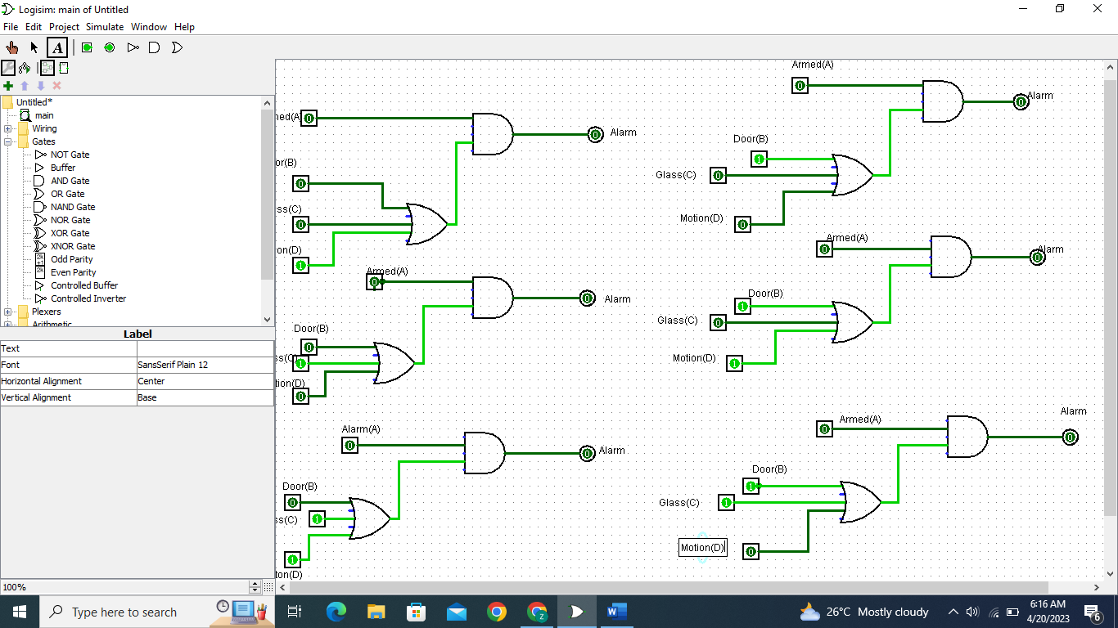

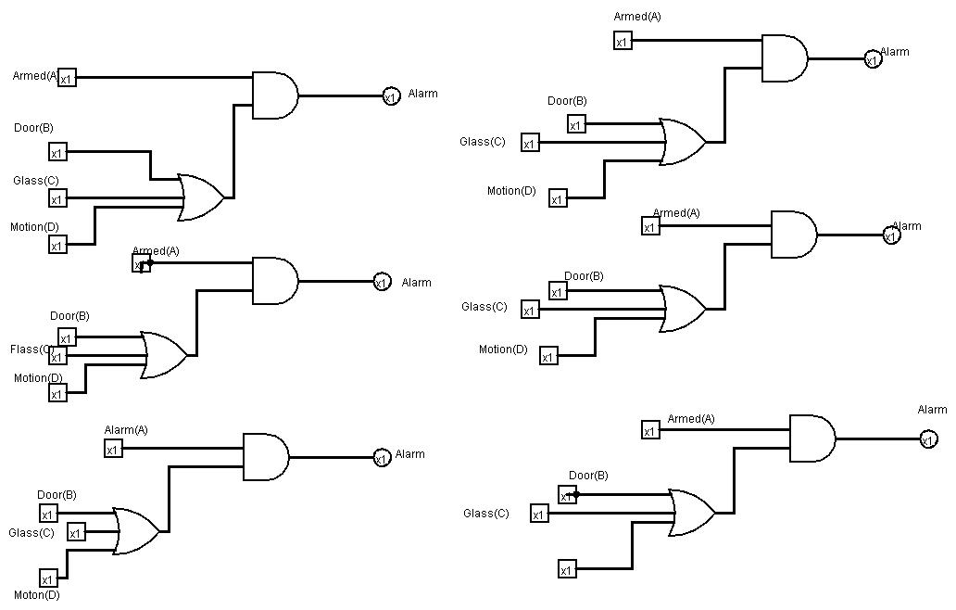

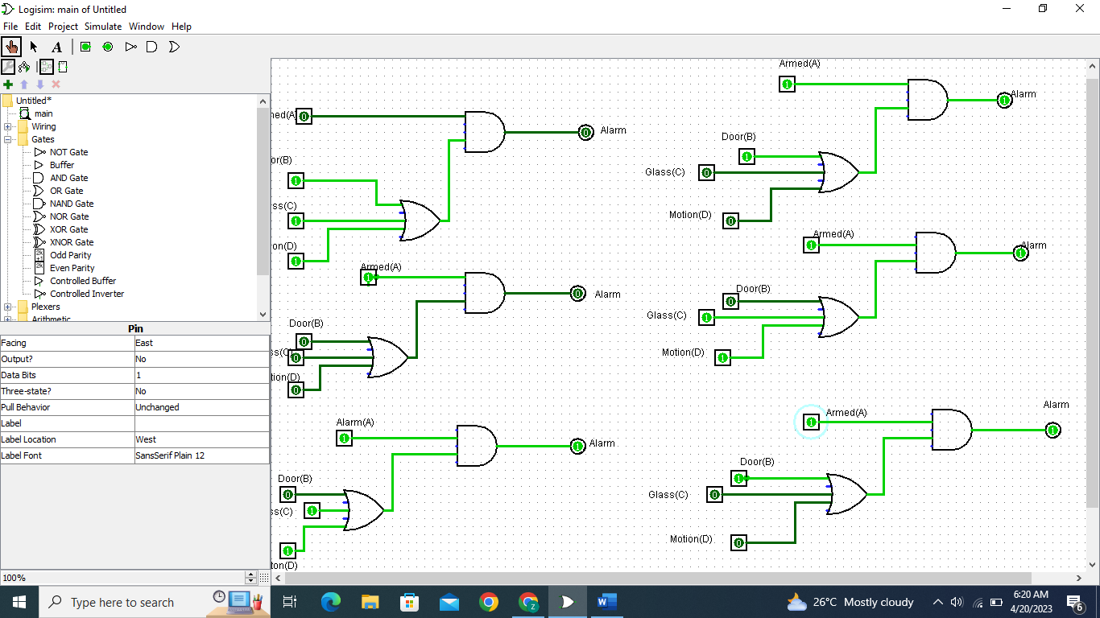

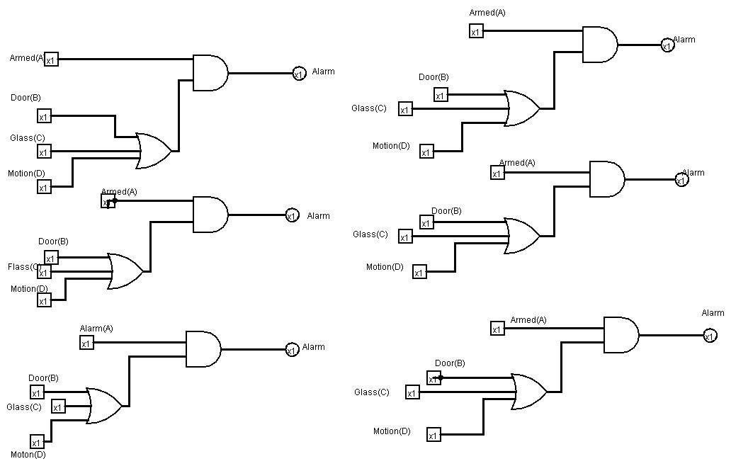

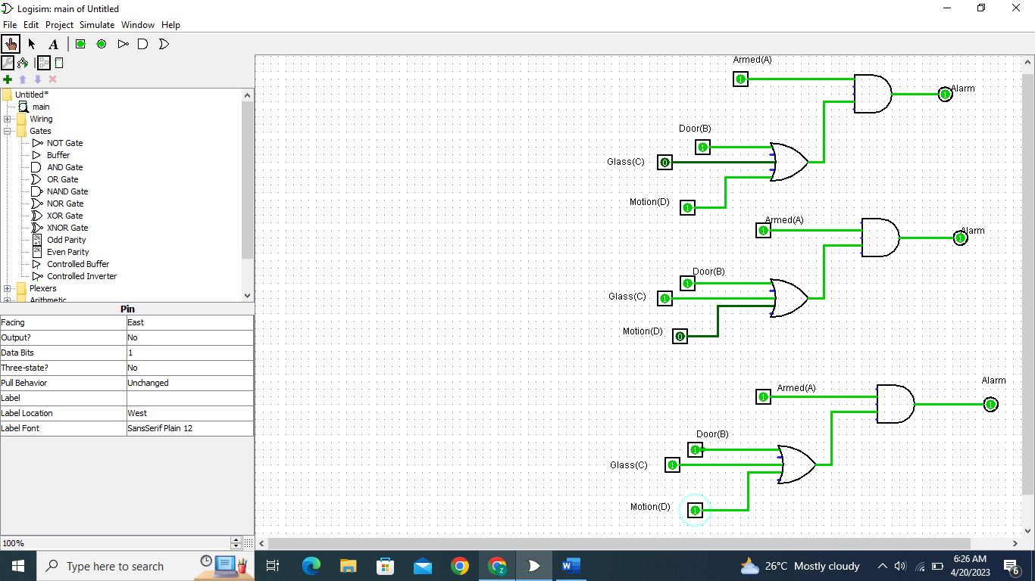

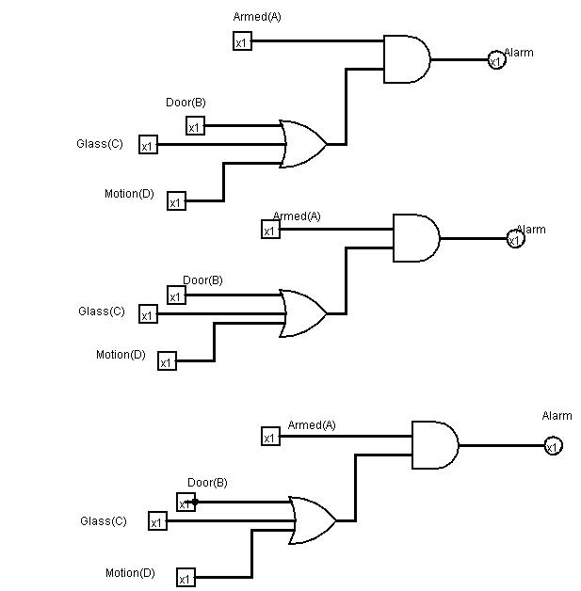

Assignment 2:

X is the output in the diagram in circuit diagram in assignment 2 question. While A, B and C are the inputs.

Circuit for Boolean equation:

|  |  |  |  |
| --- | --- | --- | --- |
| **INPUTS** | | | **OUTPUTS** |
| **A** | **B** | **C** | **D** |
| 0 | 0 | 0 | 0 |
| 0 | 0 | 1 | 0 |
| 0 | 1 | 0 | 0 |
| 0 | 1 | 1 | 1 |
| 1 | 0 | 0 | 0 |
| 1 | 0 | 1 | 1 |
| 1 | 1 | 0 | 0 |
| 1 | 1 | 1 | 0 |

The assignment 2 truth table :

When input A, B, and C are 0, output X is 0

When input A and B are 0 and C is 1, output X is 0

When input A is 0, B is 1, and C is 0, output X is 0

When input A is 0, B and C are 1, output X is 1

When input A is 1, B, and C are 0, output X is 0

When input A is 1, B is 0, and C is 1, output X is 1

When input A and B are 1, and C is 0, output X is 0

When input A, B, and C are 1, output X is 0

Assignment 3:

For the three inputs, the exclusive NOR gate is, and those three inputs exclusive of NOR gate is

a combination of AND gate and OR gate. The three inputs Boolean equation NOR gate

can also be written as;

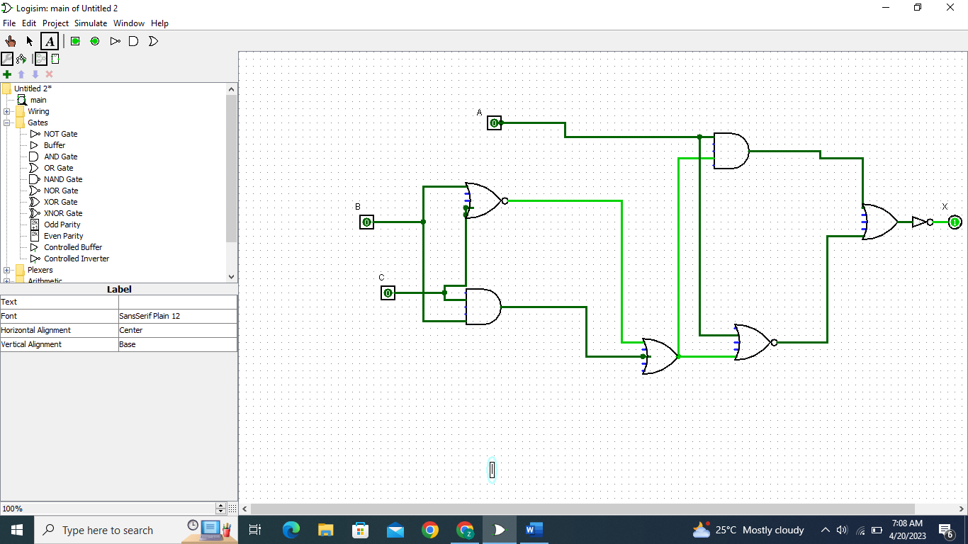

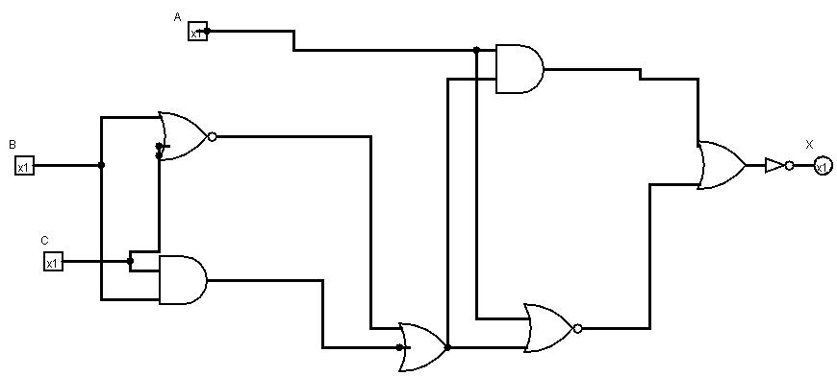

Truth table is below:

|  |  |  |  |
| --- | --- | --- | --- |
| **INPUTS** | | | **OUTPUTS** |
| **A** | **B** | **C** | **D** |
| 0 | 0 | 0 | 1 |
| 0 | 0 | 1 | 0 |
| 0 | 1 | 0 | 0 |
| 0 | 1 | 1 | 1 |
| 1 | 0 | 0 | 0 |
| 1 | 0 | 1 | 1 |
| 1 | 1 | 0 | 1 |
| 1 | 1 | 1 | 0 |

When input A, B, and C are 0, output X is 1

When input A and B are 0 and C is 1, output X is 0

When input A is 0, B is 1, and C is 0, output X is 0

When input A is 0, B and C are 1, output X is 1

When input A is 1, B, and C are 0, output X is 0

When input A is 1, B is 0, and C is 1, output X is 1

When input A and B are 1, and C is 0, output X is 1

When input A, B, and C are 1, output X is 0

References:

Electronic Tutorials (2022). Exclusive OR Gate (XOR Gate). Retrieved from <https://www.electronicshub.org/exclusive-or-gatexor-gate/>